1. Extract the “SDDiskTool-v1.7.rip” tool to the computer.



1. Insert SD card into computer. Open the SD_firmware_Tool.exe tool.

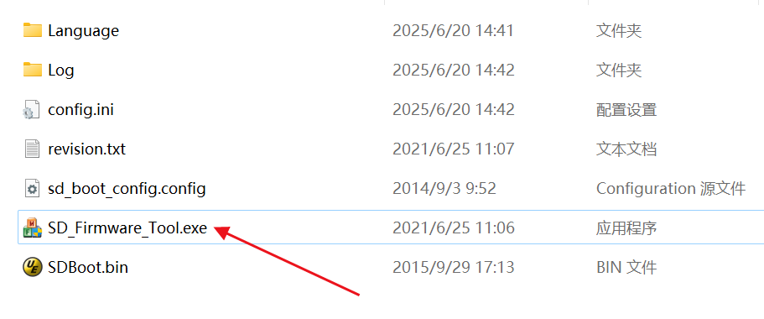

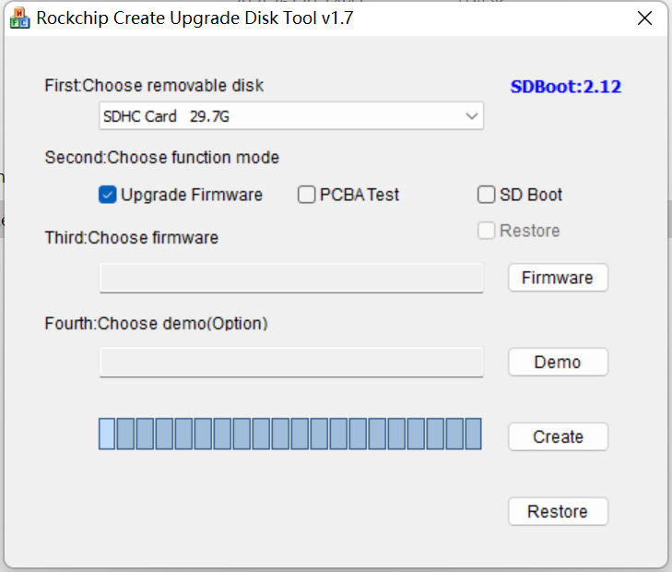

1. Click 'Restore' to format the SD card.

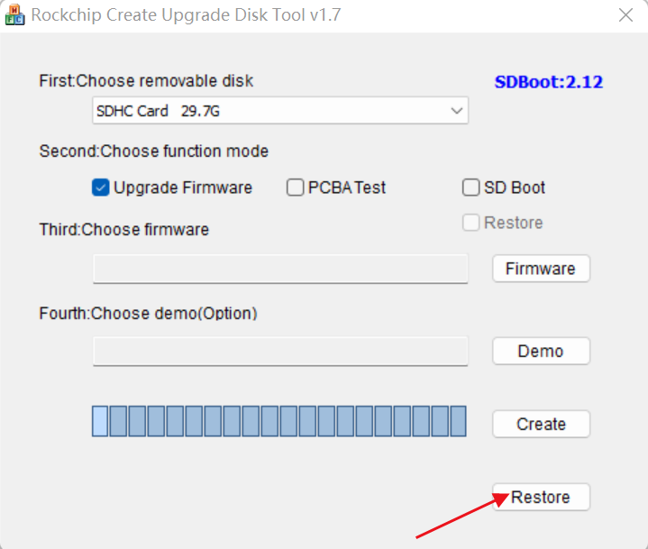

1. Select "SD Boot", click "Firmware" to load the firmware, and then click "Create" to start creating the system disk.

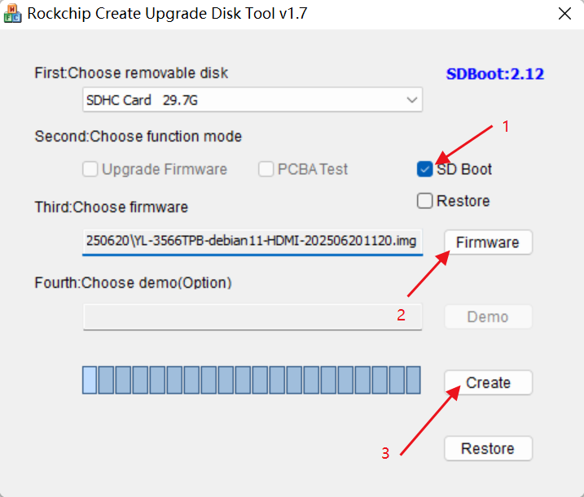

1. After the system is burned, the burning tool will pop up a prompt box. Finally, insert the SD card into the motherboard and apply 12V power to the motherboard.

